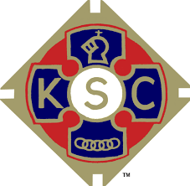

**KNIGHTS OF ST COLUMBA – COUNCIL 9**

**Are hosting their social event at Liverpool Cricket Club, Aigburth Road, L19 3QF will be held on Friday 27th June – 7 pm for a 7.30 pm start and invite Christ the King & Our Lady’s parishioners to join them.**

**The evening will include a buffet, bingo, quiz and a raffle. Tickets are £23 and can be obtained from CtK Parish Office – 722 2231 – up to 20th June.**